**Join the Excitement of *FIRST Robotics*!**

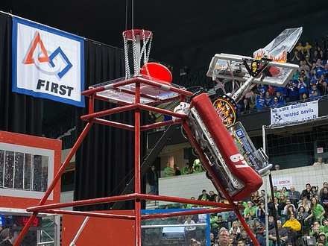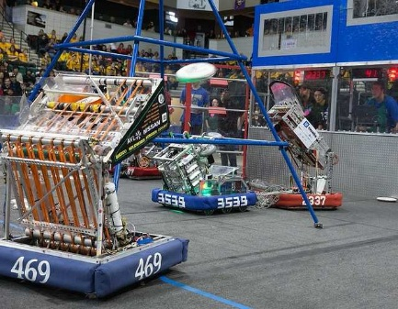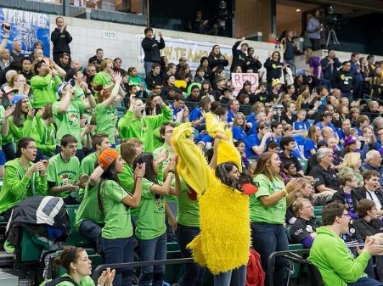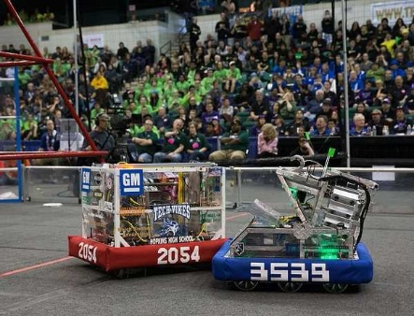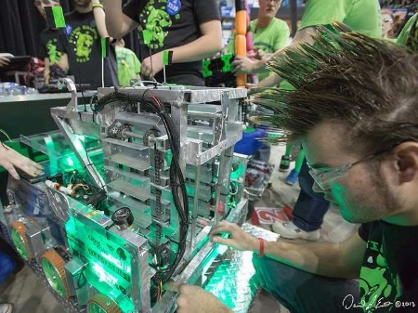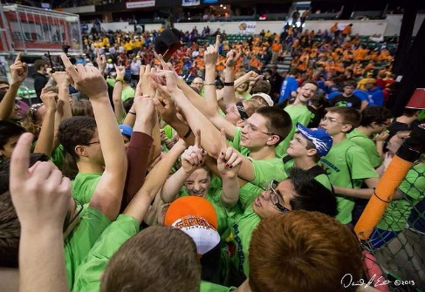

***The Capital Area Science and Mathematics Center Proudly presents FOUR New Teams in Clinton and Shiawassee Counties!***

***Teams from Corunna, Durand, Ovid-Elsie and Owosso are invited along with mentors, sponsors and community members!***

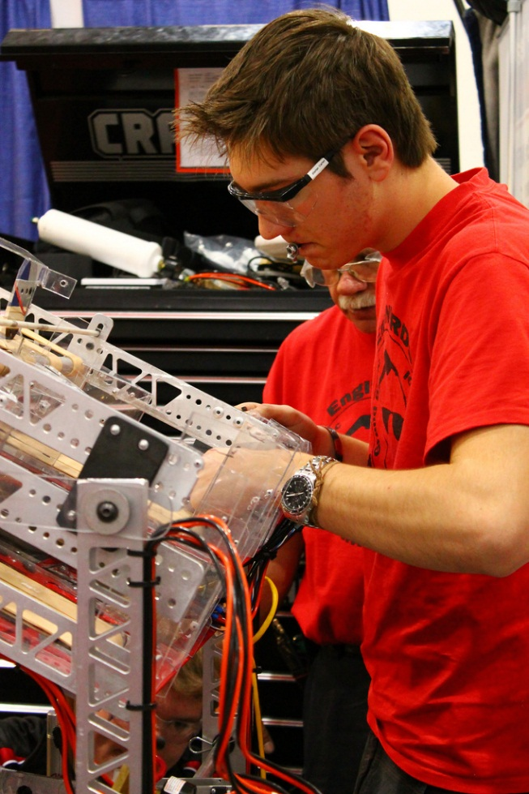**What is *FIRST*?**

*FIRST* (For Inspiration and Recognition of Science and Technology) programs inspire students to become leaders in science and technology by engaging them in mentor- based programs that inspire innovation, foster confidence, and build science, engineering and technology skills.

The *FIRST* Robotics Competition (FRC) partners high school students with sponsors and engineers to build a competition robot in six weeks. These students compete at a dozen events across Michigan, earning entry to the State and World Championships.

Find out more about the *FIRST* programs at [www.usfirst.org.](http://www.usfirst.org/)

# Program Benefits

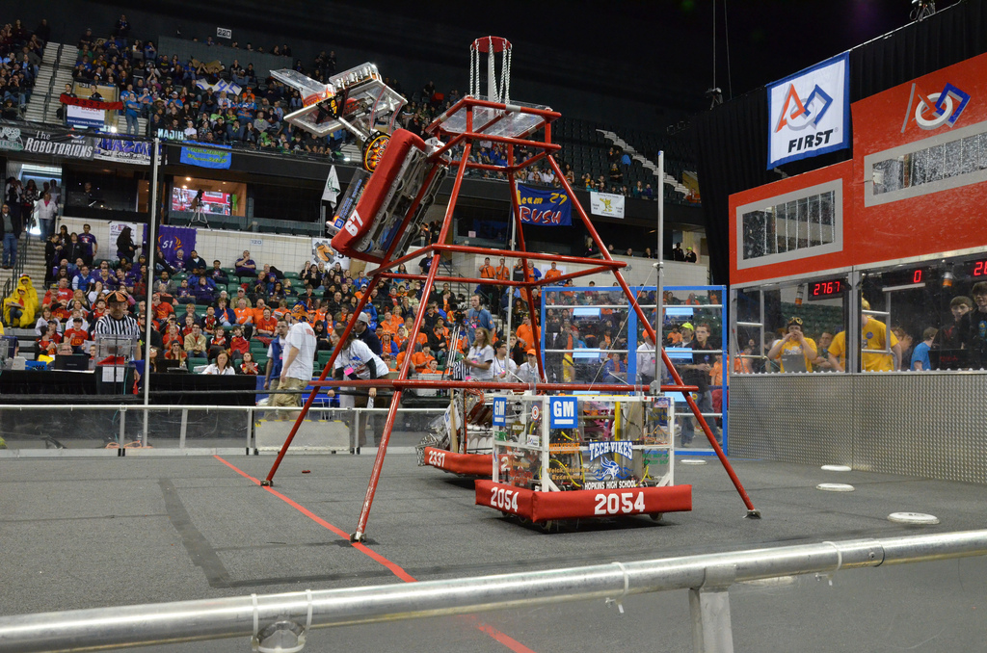Everyone benefits from involvement in *FIRST*. Nearly $16 million of scholarships are available to students. Teachers and schools network with corporate sponsors. Companies frequently hire former students for internships or full-time positions.

It is the policy of the Shiawassee Regional Education Service District (RESD) that no discriminatory practices based on gender, race,  religion, color, age, national origin, disability, height, weight, marital status, sexual orientation, political   affiliations and beliefs, or any other status covered by federal, state or local law be allowed in providing instructional  opportunities,  programs, services, job placement  assistance, employment or in policies governing student conduct and attendance.  Any person suspecting a discriminatory practice should contact the assistant superintendent for special education, 1025 N. Shiawassee Street, Corunna, MI, 48817, or call (989) 743-3471.